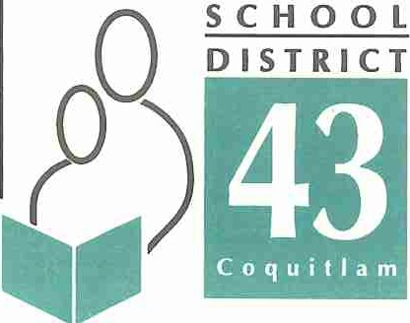

550 Poirier Street, Coquitlam, BC Canada V3J 6A7 • Phone: 604-939-9 201 • Fax: 604-937-6758

Learning for a Lifetime

September 2016

Re: New Tobacco and Vapour Products Control Act

Dear parents and students,

On September 1, 2016 the Tobacco and Vapour Products Control Act and Regulation came into effect, replacing the Tobacco Control Act and Regulation. The new Act and Regulation will restrict the display, sale and use of vapour products (or electronic cigarettes) and will be consistent with the existing laws related to tobacco. The new Act affects BC schools specifically in that: Vapour products use is not allowed at any time on public or private K-12 school sites in BC. The Act also stipulates that it is illegal to sell or give these products to anyone under the age of19.

As a result of this legislation and safety issues related to the use ofthese items, the use and possession of all vapour product and e-cigarettes on School District property is prohibited.

To read more information and the updated Act visit this website:
http: // www2.gov.be.ca /govIco ntent / hea lth/ keeping-bc-hea !thy-safe /toba cco-vapour / legislation

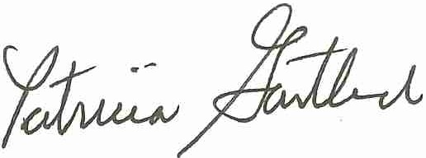Thank-you for your support. Sincerely,

Patricia Gartland
Superintendent of Schools
SCHOOL DISTRICT NO. 43 (COQUITLAM)

Serving the communities of Anmore, Belcarra, Coquitlam, Port Coquitlam and Port Moody

